QTW unit 4 Case Study

Future Contract analysis

Joshua Herrera, Matthew Payne, Remy Lagrois

2018

Abstract:

Since medieval times, future contracts have been used. Future contracts appeared in Europe during the 1600s, being very prominent during the Dutch Tulipmania event and in Japan, the Dojima Rice Exchange which was founded in 1697, hedged risk for samurai. Today, the Chicago Mercantile Exchange (CME) is the world's predominant future exchanger, and our paper focuses on analyzing the CME's gold futures data from January to March 2017. An ARIMA model was produced which generated a forecast of gold prices in our time period, and from this forecasted trend line, we can see a steady upward growth over the course of the three months. We would recommend investing in gold over the short term, however, a broader scope would be needed before any long-term advice is given.

Introduction:

The objective of this case study is to use an autoregressive integrated moving average model on our gold futures data-set. The data-set is GCH2017, from the Chicago Mercantile Exchange's futures data. The Settle variable from the data-set was used, as that is the average price at which a futures contract is traded. An ARIMA model was constructed after transforming the data to a stationary state, and the data was retroactively forecasted based on our best AR model.

Literature Review:

In order to understand this study, one must know about what future contracts (futures) are, and how futures are used. A future contract, is, as the name implies, a contract between two parties in which a commodity is bought or sold at an established price on a specified date in the future. In our case study, the commodity is gold, but futures can be of stock market indices, interest rates, currency, or other goods. At the futures exchange, parties can enter into a future contract. The purpose of entering into a future contract, as opposed to selling the commodity normally in the future, is to mitigate (or hedge) risk and to speculate gain. As an example, a farmer expects to harvest 1,000 bushels of corn at harvest season. Bushels of corn sell between the range of $3.10 and $3.70. Not knowing what the price will be at harvest season, the farmer creates a future contract with a manufacturing party, which states that at the end of October, the farmer will sell 1,000 bushels of corn at the price of $3.40 each, regardless of what the actual market price is. By agreeing upon this price, both parties are hedge the risk of the commodity's price being unfavorable to them. As this example shows, hedges have interest in the commodity being traded. The other group of people are speculators, who generally do not care about the commodity and are attempting to play the market for monetary gains.

Now that we have a basic understanding of how and why futures are established, we will explain how futures are terminated. As stated before, futures have a date on which the contract is to be fulfilled; this is known as the expiry date. [1] Upon the expiration of the contract, the contract is settled, in which the seller delivers the commodity to the buyer; this rarely happens. Most traders will take one of two other options for their futures: offsetting, and rolling over. Offsetting the position is the most common method of exiting the contract. Going back to the corn example, say now that the buyer is not a manufacturer, and is instead a private citizen with no need for 1,000 bushels of corn. If the contract were to expire, the farmer would deliver such a large quantity, that the citizen would not have any means to store the corn, let alone be able to use it. He is a speculator who thinks that the price of corn will be lower than $3.40. In order to offset a position, there must be an equal and opposite transaction of the contract with the same expiry date. Before the contract expires, the speculator sees that there is another contract for the same corn which expires in October. These corn futures, however, are $3.30. To offset the original contract, the speculator would buy 1,000 bushels at $3.30, and sell them for $3.40, making $0.10 per bushel in profit.

The other option one has before a contract expires is to rollover. [2] A rollover is similar to an offset, in which the buyer offsets their position, however, they re-purchase the futures for an upcoming month. As a new example, you are a seller of gold: your gold future contract expires this month and the price is $1,100. You can rollover your contract by selling for $1,100 and buying a future three months from now for $1,200. By enacting this transaction, you are speculating that the price of gold will be greater than $1,200 and you will make a profit. [3] Rolls forward are different than offsetting and purchasing a new future because the transaction occurs simultaneously, which reduces slippage, which is a loss in profit that occurs due to trading, with implications on supply and demand.

Methods:

First, the settle price data was checked to see if it was stationary using the Dickey-Fuller test. With a p-value of 0.92 it was determined not to be stationary. Because we need stationary data to perform an ARIMA model, a log transformation was applied, and the moving average was subtracted from the logarithmic data (Fig. 1). [4] The result was tested using the Dickey-Fuller test; resulting in a p-value of 0.019.

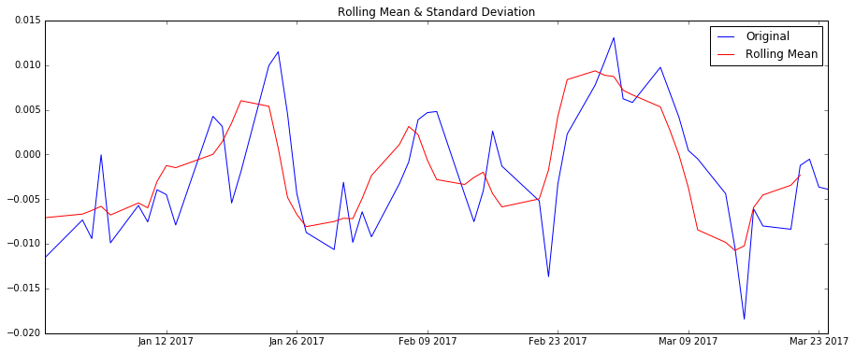

Figure 1 Settle Price with Applied Transformation

Therefore, the data were determined to be stationary and this transformation was used in the development of the ARIMA models.

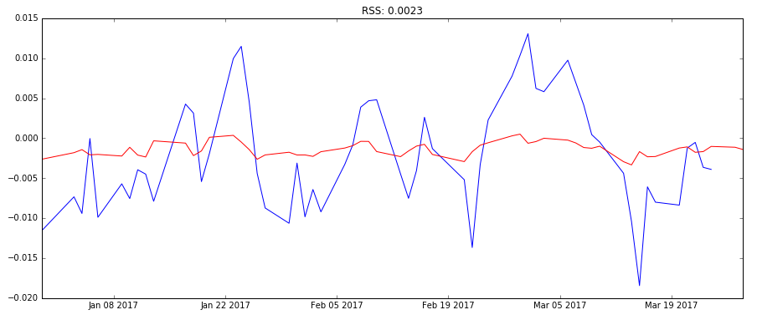

Figure 2 AR Model

First, an AR model was developed, and the residual sum of squares (RSS) was calculated which came out to 0.0023 (Fig. 2). Next the MA model was generated, and the RSS was calculated to be 0.0024 (Fig. 3). Finally, a combined model was also developed but required a change in the order causing it to not reflect the data as accurately as either the AR or the MA models.

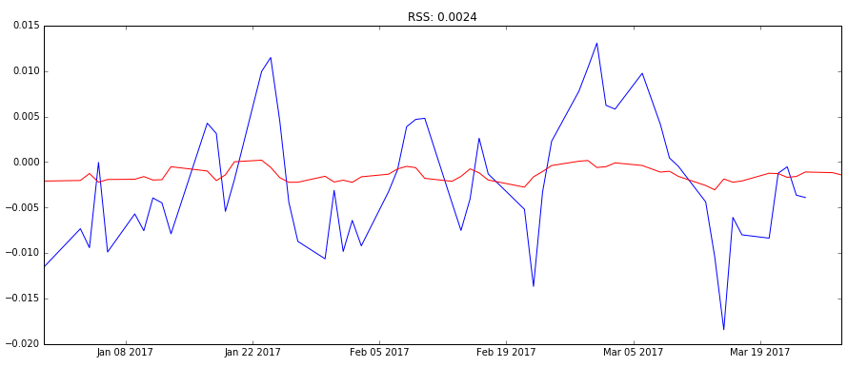

Figure 3 MA Model

Results:

After comparing the AR and the MA models, the AR model was chosen as our preferred model, due to it having the lowest residual sum of squares. A lower RSS means that there is less of a discrepancy between the model and the data. The AR model then produced a forecast (Fig. 4). This forecasted green line was derived from all prior dates and has a steady upward growth, indicating a rising price of gold over the course of the three months of this futures contract.

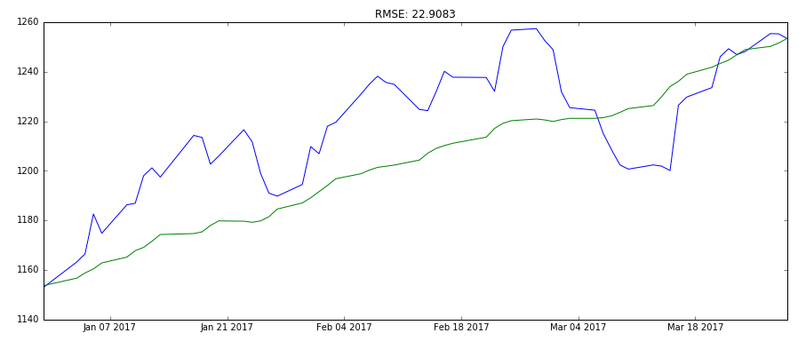

Figure 4 AR Model with Forecast

Conclusion:

Because the window of this futures contract was only three months, we can only recommend on a short-term basis. We can infer that the price of gold will continue to increase; however, there may be more dramatic up-or-downs on a day to day basis. So, investing in gold in the short to medium term may be recommended but the model is not accurate enough to exploit rapid fluctuations in day to day pricing. If one wishes to invest in gold over multiple years, it would be best to examine other contracts with longer expiry dates.

Future Work:

To improve the performance of our model we would need continuous futures data generated from rolled contracts. The code from Python for Data Analysis Chapter 11 related to Future Contract Rolling was fraught with errors and could not be used for this case study. Although we extensively researched how to calculate future contract rolls, all the resources related to this topic were outdated. Further research revealed that financial data suppliers like Quandl now offer continuous rolled futures data for premium users. Accessing futures data to calculate when to roll is no longer something that you must calculate yourself as the data is provided with a variety of rolling methods. Because continuous futures contract data is accessible directly, there are not many open source projects focusing on this topic. The data provided by Quandl allows you to select forward or backwards adjusted prices with ratio or weights that you prefer for nearly any futures product. The research in this field is proprietary and is not freely available to researchers. We would improve our forecasting in future work by exploring the financial domain further to locate open source resources.

References:  
  
[1] CME Group, “Understanding Futures Expiration & Contract Roll,” *CME Group*, 31-Jan-2018. [Online]. Available: <https://institute.cmegroup.com/courses/introduction-to-futures-html/modules/understanding-futures-expiration-contract-roll>. [Accessed: 06-Feb-2018].

[2] A. H. Grimes, “Roll em! How to calculate futures rolls (and why you care),” *AdamHGrimes*, 10-Feb-2017. [Online]. Available: <https://adamhgrimes.com/how-to-calculate-futures-rolls/>. [Accessed: 06-Feb-2018].

[3] FuturesTradingpedia, “Roll Forward,” *FuturesTradingpedia*. [Online]. Available: <http://www.futurestradingpedia.com/futures_roll_forward.htm>. [Accessed: 06-Feb-2018].

[4] A. Jain, A. Choudhary, G. Blog, and P. Dar, “Complete guide to create a Time Series Forecast (with Codes in Python),” *Analytics Vidhya*, 04-May-2017. [Online]. Available: https://www.analyticsvidhya.com/blog/2016/02/time-series-forecasting-codes-python/. [Accessed: 06-Feb-2018].

Appendix:

iPython Notebook Attached Separately